### AVIONICS BAY

The avionics bay is the part of the rocket that is designated to house the avionics, switches, batteries, trackers, electronics and all the necessary wiring in the rocket. The printed circuit boards, wiring and batteries are secured on a wooden-sledges and fastened with zip ties and tuck nails.

The bay was designed with the thought of having an easy assemble and disassemble of the components within the avionics chamber of the rocket. Autodesk Fusion 360 CAD was used for the design after an iterative on paper parameter and dimension determination.

The dimensions of the avionics bay were determined by:

* The size of the avionics chamber in the rocket
* The diameter of the fuselage
* The size of the PCB boards for power, telemetry and flight ejection systems
* The Ejection systems length
* Ease of assembly within the fuselage

The following are the CAD design specifications listed below:

* + - 1. Couplers (top and bottom)
* The coupler will be used to orient the bay to the cylindrical shape of the airframes. They were of different sizes for both the Aluminium and the GFRP.
  + ALUMINIUM
    - The Aluminium airframe has an internal diameter of 80mm. therefore for easy installation of the bay into the fuselage, we went with a coupler of 75mm external diameter.

* + GFRP
    - The Fibreglass airframe has an internal diameter of 84mm. therefore for easy installation of the bay into the fuselage, we went with a coupler of 80 mm external diameter.
      1. The wooden sledge
* The altimeters are situated within the PCB’s housed on the wooden sledges. The antennas and receivers will be placed outside the fuselage. The wooden sledge is held in its flight configuration using standoffs slotted as wedges on its upper section. The dimensions of the wooden sledge differ for both the GFRP and the Aluminium airframes.
  + - * + ALUMINIUM
        + The design specifications are as shown below:

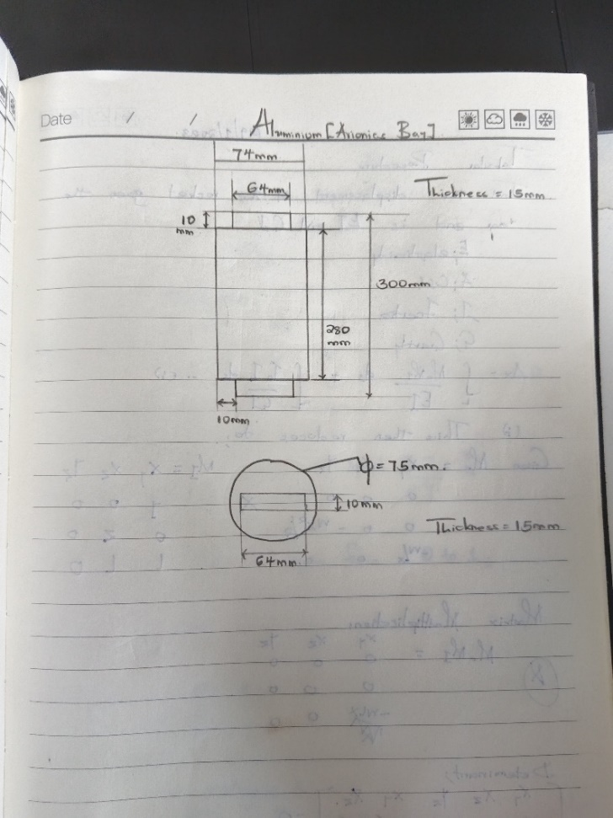

* + - * + GFRP
        + The design specifications are as shown below:

